22nd October 2018

**YOKOHAMA Tires Coming Factory-Equipped on German Premium Car Maker’s New Model Being Made in China**

YOKOHAMA is supplying “ADVAN Sport V105” tyres made at its Suzhou Plant in China as original equipment (OE) for use on the new BMW X3 Midsize Sports Activity Vehicle made at the German automaker’s plant in China. The Suzhou Plant began supplying 245/50R19 105W size tyres for the China-made X3 in May 2018.   
  
The “ADVAN Sport V105” is a high-performance tyre developed by YOKOHAMA primarily for use on high-power premium automobiles. The tyre delivers excellent driving performance combined with superior comfort and safety. The tyres being supplied for the new X3 were jointly developed with the BMW Group and bear the German automaker’s star mark symbol of approval on the tyre sidewall.   
  
Under its three-year medium-term management plan, GD2020, launched in February 2018, YOKOHAMA has positioned the expansion of its presence in the premium tyre markets as the core goal for its consumer tyre business. One of the specific strategies for achieving that goal is the “premium-car tyre strategy”, which aims to increase use of YOKOHAMA tyres as OE on premium cars in Japan and abroad by making YOKOHAMA the tyre maker chosen by automakers around the world in recognition of its technologies and quality.

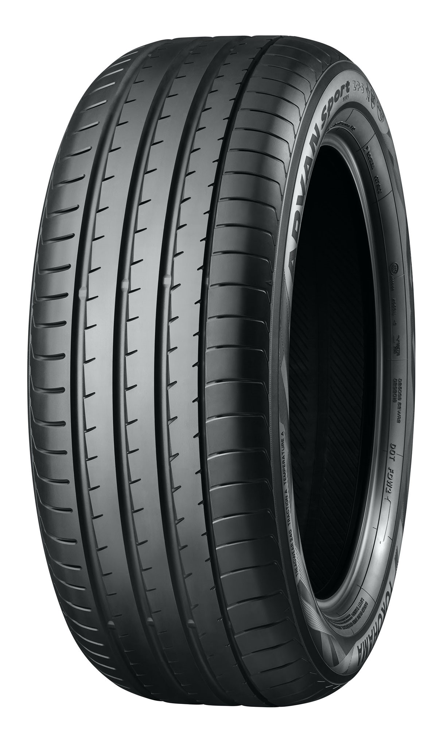

*“ADVAN Sport V105” tyres being used as OE on new BMW X3 (The photo is “ADVAN Sport V105” produced at the Shinshiro Plant in Japan)*